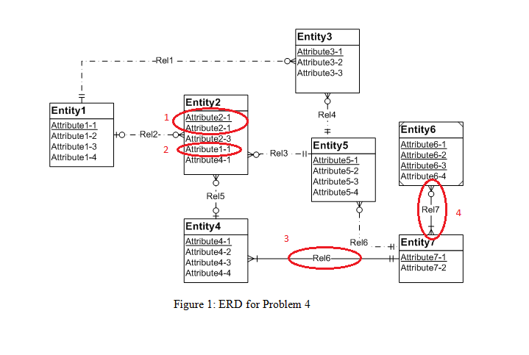

1.Entity Name rule Violation-Attributr name should be changed

2.foreign key rule violation-because attribute1-1 is a primary key in entity 1

3.Identifying Relationship rule violation-The problem can be resolved by adding one or more weak entities or making the relationship (Rel6) non-identifying.

4.identification dependency cardinality rule: The problem can be resolved by changing the weak entity’s cardinality in Rel7 to (1,1).